Level 1: Level 2:

Easy 7x7 70% Hard 7x7 70%

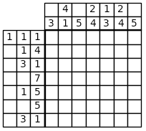 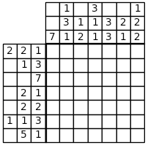

Level3 Level 4:

Easy 7x7 50% Hard 7x7 50%

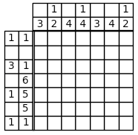 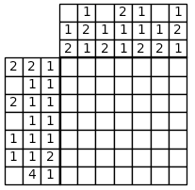

Level 5:

Easy 10x10 70%

